Download Result
Step 1. Click on the below link for login to student portal.
https://portal.svkm.ac.in/usermgmt/loginSvkm
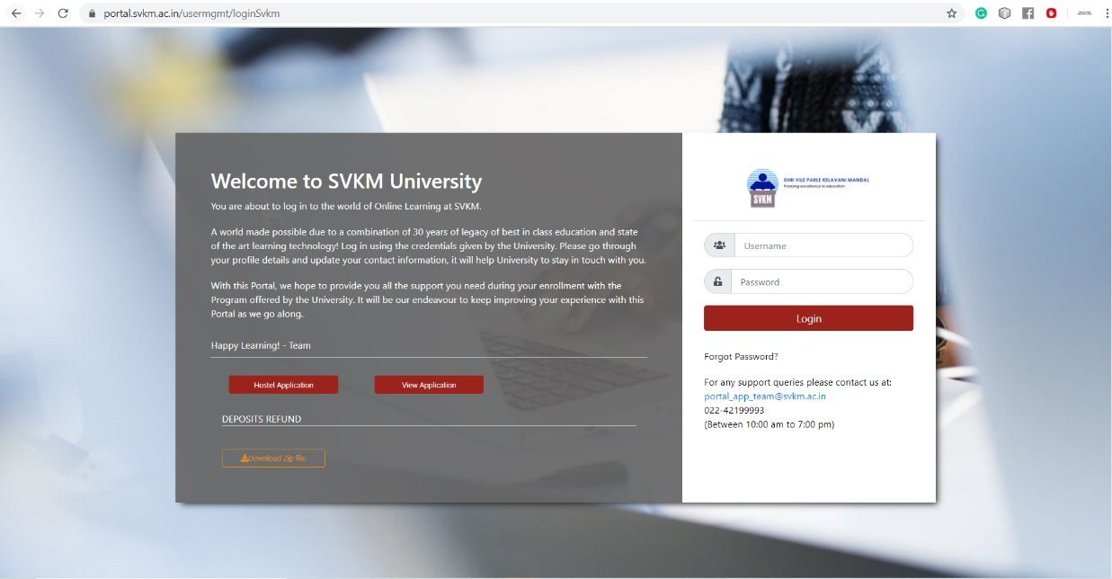
Step 2. After visiting on URL you're able to view the login page

- Enter your username(sapid) and password.
- After putting correct username and password click on the Login Button

Step 3. If student marksheet is available then only student is able to download from the portal. (Download icon visible)
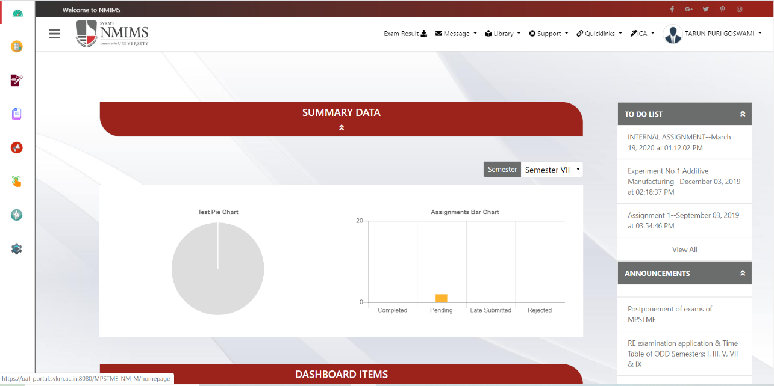
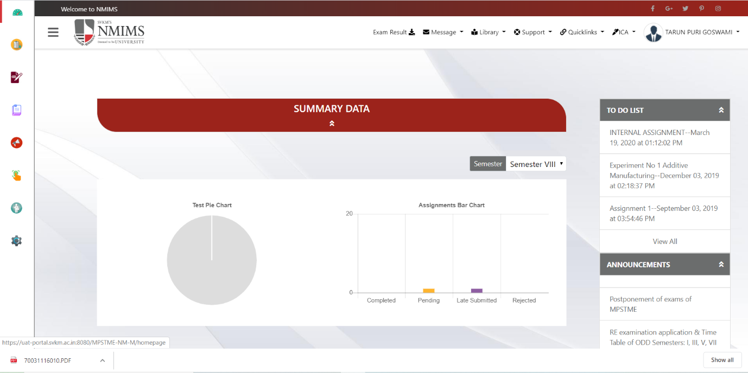
- Click on Exam Result Option after the clicking result will be download.

Step 4. If student marksheet is not-available (Download icon not - visible).
